Lesson 07 Demo 1
Setting up Ansible
Objective: To install Ansible and set up in your system

Pre-requisites: You need to have Python 2.7 or higher, Minimum 8 GB RAM, and SSH or SCP communicator.

Steps to be followed:
- Install Ansible
Step 1: Install Ansible
1.1 Use the below command to check and find the dependencies of the packages you want, and install any that are needed
sudo apt-get install -f
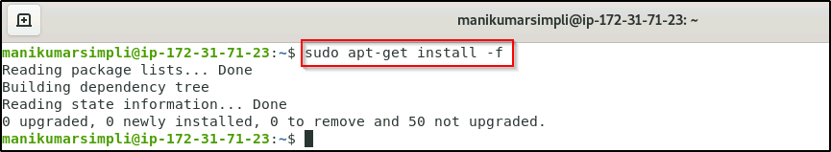
1.2 Use the below command to update package repositories and get latest package information
sudo apt-get install software-properties-common
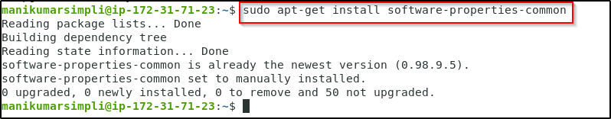
1.3 Run these commands to update the list of available software once again and install Ansible. It also pulls down Ansible PPA's signing key and adds it to your system
sudo apt-add-repository ppa:ansible/ansible
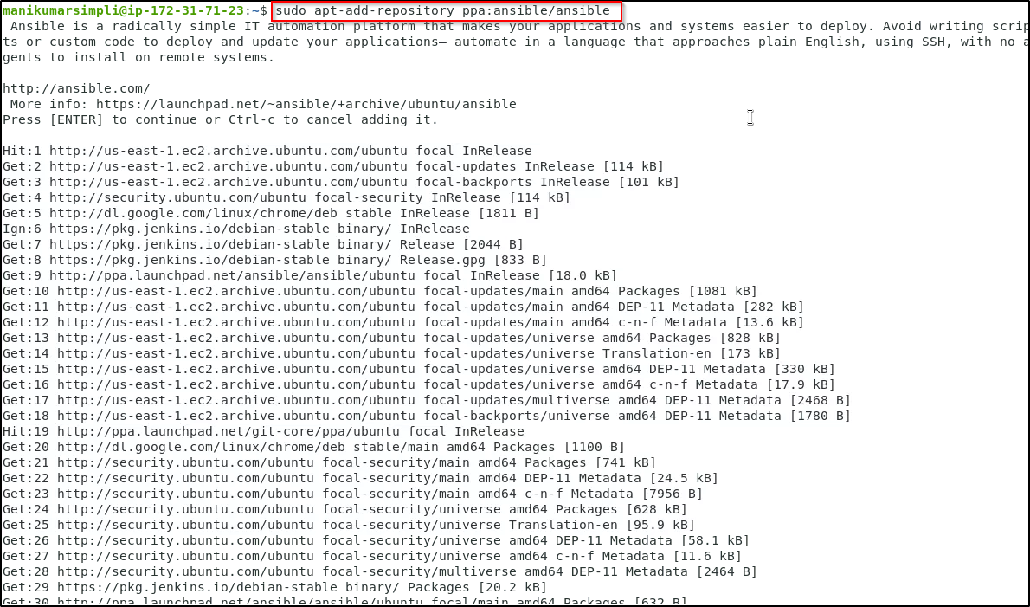
1.4 Use the below command to download package information from all configured sources
sudo apt-get update
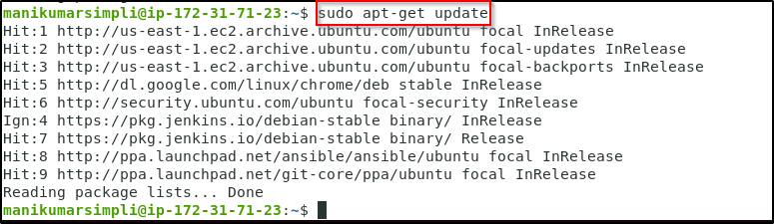
1.5 Use the below command to install Ansible
sudo apt-get install ansible

